ASSIGNMENT IV

UltrasonicSensor

TEAM ID: PNT2022TMID54090

Name : Mohan raj.m

REGN0:111919106039

**CODE:**

#include <WiFi.h>#include<PubSubClient.h>WiFiClient;

#defineORG"nhpwjc"

#define DEVICE_TYPE "NodeMCU"#defineDEVICE_ID"USEYOURID"#defineTOKEN"USEYOURTOKEN"

#definespeed0.034

charserver[]=ORG

".messaging.internetofthings.ibmcloud.com"; charpublishTopic[] = "iot-2/evt/Data/fmt/json"; char topic[] ="iot-2/cmd/home/fmt/String";charauthMethod[]="usetoken-auth";chartoken[]=TOKEN;charclientId[]="d:"ORG":"DEVICE_TYPE ":" DEVICE_ID; PubSubClient client(server,1883,wifiClient);voidpublishData(); const inttrigpin=5;

constintechopin=18;String command;Stringdata="";

longduration;float dist;voidsetup()

{

**Serial**.begin(115200);pinMode(trigpin,OUTPUT);

pinMode(echopin, INPUT);wifiConnect();mqttConnect();

} void loop() {

publishData();delay(500);if(!client.loop()){

mqttConnect();}}

voidwifiConnect(){

**Serial**.print("Connecting to "); **Serial**.print("Wifi");WiFi.begin("Wokwi-GUEST","",6);while(WiFi.status()!=WL_CONNECTED){delay(500);

**Serial**.print(".");}

**Serial**.print("WiFiconnected,IPaddress:");**Serial**.println(WiFi.localIP());

}

void mqttConnect() { if(!client.connected()){

**Serial**.print("Reconnecting MQTT client to "); **Serial**.println(server); while(!client.connect(clientId,authMethod,token)){**Serial**.print(".");delay(500);

}initManagedDevice();

**Serial**.println();}}

voidinitManagedDevice(){if(client.subscribe(topic)){

// Serial.println(client.subscribe(topic)); **Serial**.println("subscribe to cmdOK");

}else{

**Serial**.println("subscribe to cmd FAILED"); } }voidpublishData()

{ digitalWrite(trigpin,LOW);digitalWrite(trigpin,HIGH);

|  |  |
| --- | --- |
| delayMicroseconds(10); digitalWrite(trigpin,LOW);duration=pulseIn(echopin,HIGH);dist=duration*speed/2;if(dist<100){String  payload="{\"Alertdistance\":";payload+=dist;payload+="}";  **Serial**.print("\n");  **Serial**.print("Sendingpayload:");**Serial**.println(payload);if(client.publish(publishTopic,(char*) payload.c_str()))**Serial**.println("PublishOK");  }else{  **Serial**.println("PublishFAILED");}}  } | { |

# CONNECTIONS:

X

# OUTPUT:

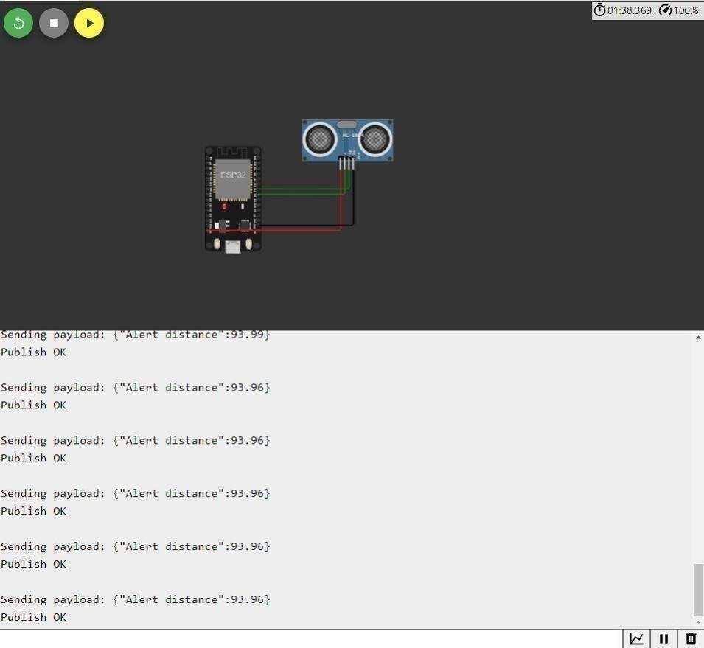

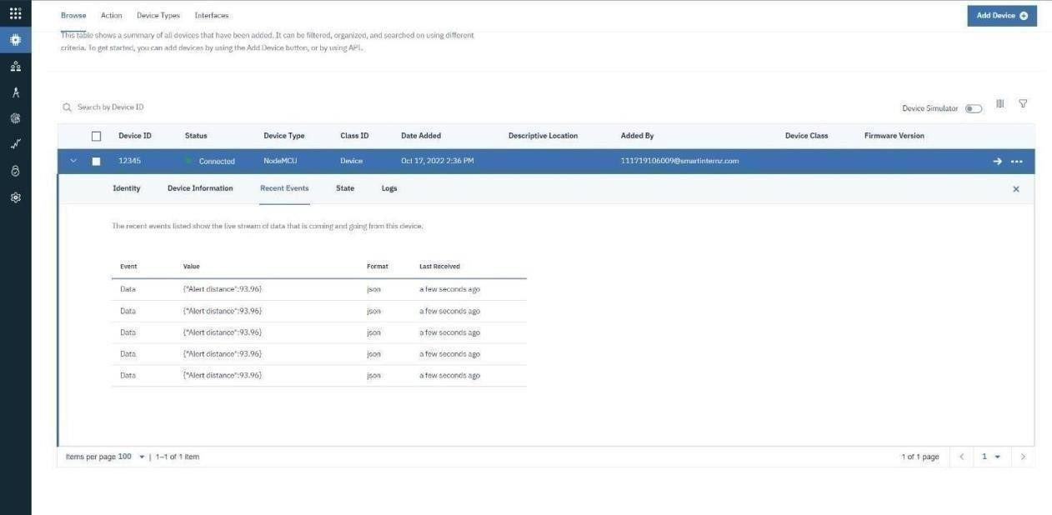

**WOKWILINK-<https://wokwi.com/projects/346405970317935188>**